**DUBLIN CORE**

**Dublin Core (DC): What is it?**

There are fifteen metadata (data that describes data) terms in the Dublin Core international metadata standard, which was formerly known as the Dublin Core Metadata Element Set. For search engine programmes, these terms provide enhanced document indexing and more comprehensive cataloguing information.

The 15 metadata terms that make up Dublin Core offer a robust catalogue for describing online resources, enhancing search engine optimisation (SEO), and combining metadata from various standards. The terms are referred to as DCMI metadata terms (or simply Dublin Core terms), along with "extension vocabularies." Numerous properties, classes, data types, and vocabulary encoding schemes are included in these vocabularies.

**Dublin Core comes in two varieties:**

Dublin Core in simplicity. It uses only the fifteen metadata elements from the Dublin Core Metadata Element Set to express elements as attribute-value pairs.

Dublin Core qualified. To improve the specificity of metadata, it includes details about encoding schemes, enumerated lists of values, or other processing hints. Qualifiers make searches more precise, but they are also more complicated and may cause problems with interoperability.

Dublin Core has developed into an ISO standard over time. It acknowledges that a resource description's language is typically the language of metadata. It has a registry with definitions in over 20 languages in order to achieve this goal.

Resource discovery should be independent of the resource's medium, according to Dublin Core's long-standing stance. Therefore, even though its primary focus is on electronic resources, it also aims to be adaptable enough to support searches for more conventional data formats, such as books, CDs, videos, images, and artwork. However, the most frequent users of Dublin Core are websites.

**The Dublin Core Metadata Initiative: What Is It?**

The Dublin Core Metadata Initiative (DCMI) is in charge of creating and maintaining Dublin Core. Creating metadata standards to describe physical resources like books and CDs and digital resources like webpages is the work of the independent, nonprofit, public DCMI. It is an open organisation that creates online metadata standards that are compatible to make information management, sharing, and search easier on the web.

The Association for Information Science and Technology is the sponsor of the organisation (ASIS&T). Furthermore, it is overseen by a board of directors, run by an executive, and cultivates partnerships with global metadata organisations and standards bodies to promote alignment standards for the global digital ecosystem.

**Dublin Core's history**

At the 2nd International World Wide Web Conference in Chicago in 1994, talks involving executives from the National Centre for Supercomputing Applications, the organisation that represents libraries, and other organisations laid the foundation for the Dublin Core. There were only roughly 500,000 addressable objects on the internet at the time. However, despite this small number, users frequently had trouble locating the resources they required. During the conference, a panel discussion created the framework for resolving these issues.

These early conversations in Chicago sparked a workshop on web-based metadata semantics in Dublin, Ohio, in 1995. The workshop's primary goal was to investigate whether a core set of semantics could aid in web categorization, making it simpler to search and retrieve web content. Because of the location of the workshop, these semantics, or metadata, were called Dublin Core metadata.

The workshop format was expanded in 2001 to offer more chances for idea sharing and the creation of additional Dublin Core metadata standards. As the de facto organisation for creating web metadata standards, the DCMI has been maintaining its own documentation for DCMI Metadata Terms since 2002. In order to create specifications related to metadata, such as encoding syntaxes, usage guidelines, and metadata models, numerous DCMI working groups have been formed over time.

**Dublin Core metadata set**

There are 15 terms in the Dublin Core, along with several properties, classes, data types and vocabulary encoding schemes. These terms form a metadata schema that can be used to describe both physical and digital resources.

The 15 metadata elements in Simple Dublin Core are given below:

| **Number** | **Element** | **Meaning** |
| --- | --- | --- |
| 1 | Title | The name given the resource |
| 2 | creator | The person or organization responsible for the content |
| 3 | subject | The topic covered |
| 4 | description | A textual outline of the content |
| 5 | publisher | Those responsible for making the resource available |
| 6 | contributor | Those who added to the content |
| 7 | date | When the resource was made available |
| 8 | type | A category for the content |
| 9 | format | How the resource is presented |
| 10 | identifier | Numerical identifier for the content, such as a URL |
| 11 | source | From where the content originally derived |
| 12 | language | In what language the content is written |
| 13 | relation | How the content relates to other resources -- for instance, if it is a chapter in a book |
| 14 | coverage | Where the resource is physically located |
| 15 | rights | A link to a copyright notice |



|  |  |
| --- | --- |
| **TITLE:** | **“A cat”** |
| **DESCRIPTION:** | **A portrait of a cat** |
| **CREATOR:** | **Johan Iskandar** |
| **DATE CREATED:** | **10 July 2019** |
| **SUBJECT:** | **Cat** |
| **KEYWORDS:** | **Portrait, cat** |
| **IDENTIFIER:** | **photo_6269474130202049754_y** |
| **SOURCE:** | **DSLR camera** |
| **RIGHT:** | **Copyright Johan Iskandar, All Right Reserved** |
| **FORMAT:** | **IMG** |
| **SIZE:** | **6.6 MB** |
| **LOCATION:** | **PETALING JAYA, SELANGOR** |
| **OWNERSHIP:** | **Johan Iskandar Photography** |

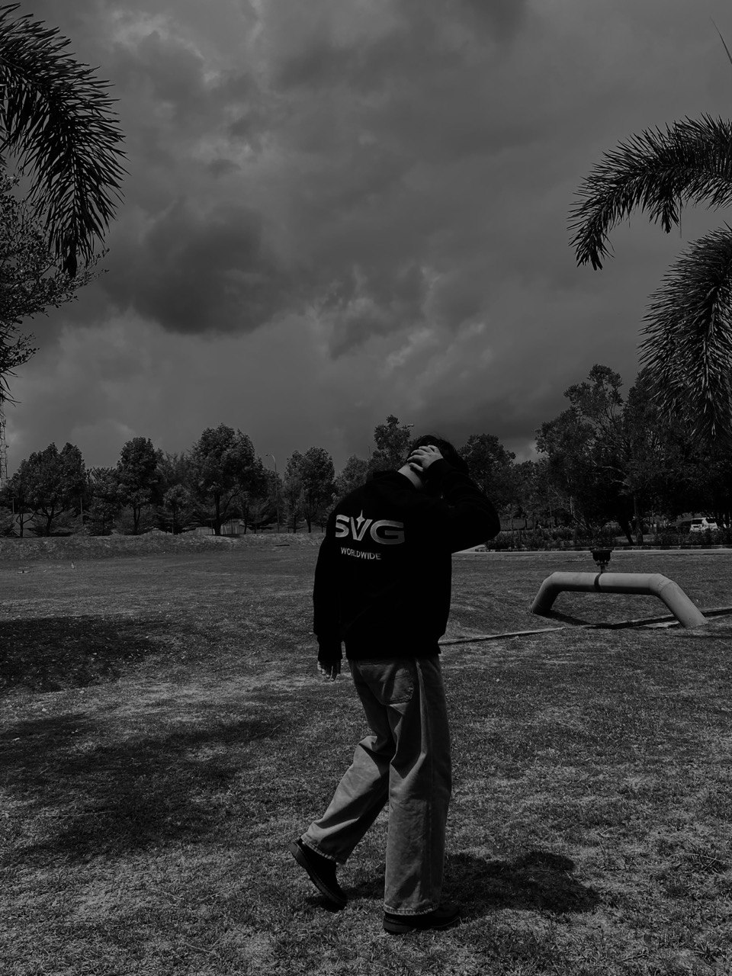

|  |  |
| --- | --- |
| **TITLE:** | “Portrait of a person” |
| **DESCRIPTION:** | A cool style of picture with a black and white filter |
| **CREATOR:** | Johan Iskandar |
| **DATE CREATED:** | April 23, 2024 |
| **SUBJECT:** | Sky, Tree, black and white |
| **KEYWORDS:** | Sky, Tree, black and white, portrait |
| **IDENTIFIER:** | photo_6165806659197320677_y |
| **SOURCE:** | Phone camera |
| **RIGHT:** | Copyright Johan Iskandar, All Right Reserved |
| **FORMAT:** | JPG |
| **SIZE:** | 190 KB |
| **LOCATION:** | 5.7138° N, 100.4505° E (UiTM Kedah) |
| **OWNERSHIP:** | Johan Iskandar Photography |